**Advanced Selectors**

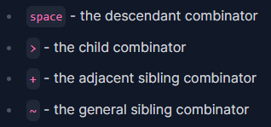Important games: CSS Dinner

1. **Combinators**

Example:

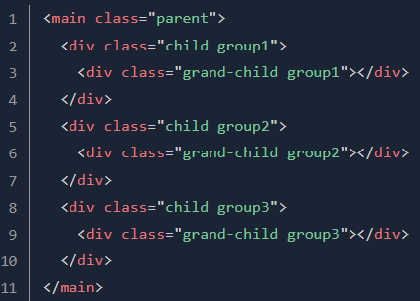

Following: muncul setelah

1. Descendant (keturunan)



This will select all ‘child’ and ‘grand-child’ <div> inside of <main>

1. Child (anak)



This will only select direct children(of main, which is div with class ‘.child’)

1. Adjacent sibling (saudara terdekat)

To select an element that is (following) adjacent on the same level of indentation.



This will only select the div with the class child group2



This will only select the div with the class child group3

1. General sibling (saudara umum)

To select all of the siblings following an element.

This will select all of .group1 siblings - in this case the 2nd and 3rd .child div

1. **Pseudo-selectors**
2. Pseudo-classes ( :single-colon )

Untuk memilih elemen berdasarkan keadaan tertentu. Misal saat elemen dalam keadaan hover, fokus, atau saat elemen adalah anak pertama

1. 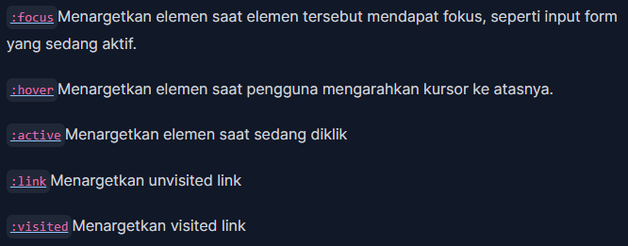Dynamic & user action

These can make your page feel much dynamic and interactive

1. Structural pseudo-classes

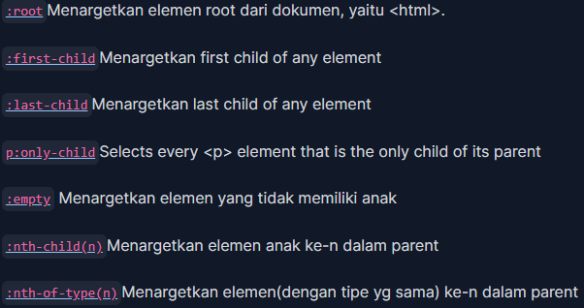A powerful way to select elements based on their position within the DOM.

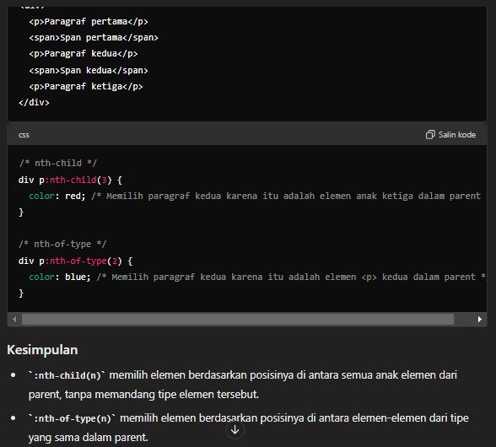Perbedaan :nth-child(n) & :nth-of-type(n)

1. Pseudo-elements ( :double-colon )

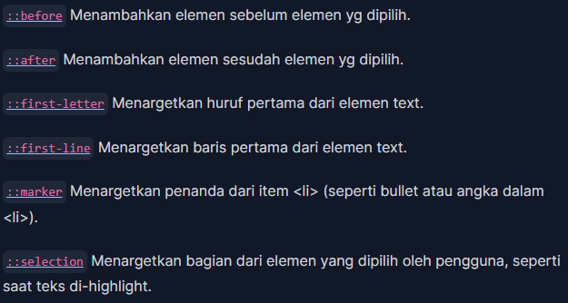Untuk menata bagian spesifik dari elemen yang sudah ada. Mereka memungkinkan developer untuk membuat elemen yang sebenarnya tidak ada dalam markup HTML, seperti menambahkan konten sebelum atau sesudah elemen, atau menata huruf pertama dari paragraf.

1. **Attribute Selectors**

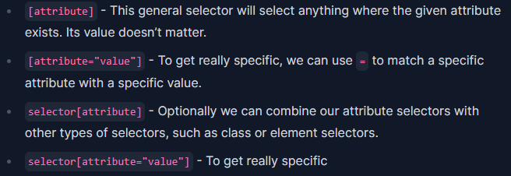Attribute is anything in the opening tag of an HTML element, such as src='picture.jpg' or href="www.web.com".

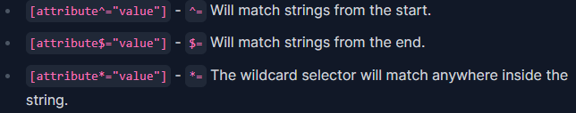Based on how we access:

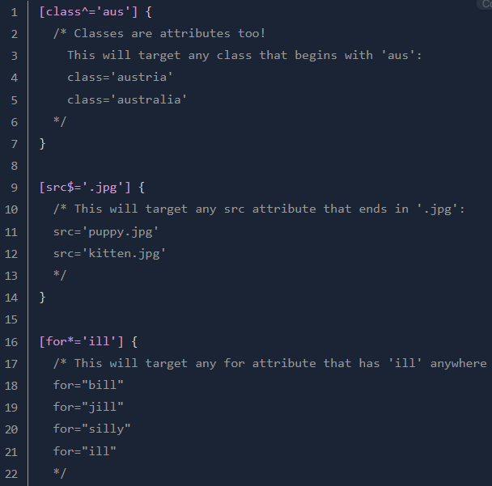Example:

